**Climate and YOUth Summit 2024   
The role of youth in climate action  
(11 December, concept note)**

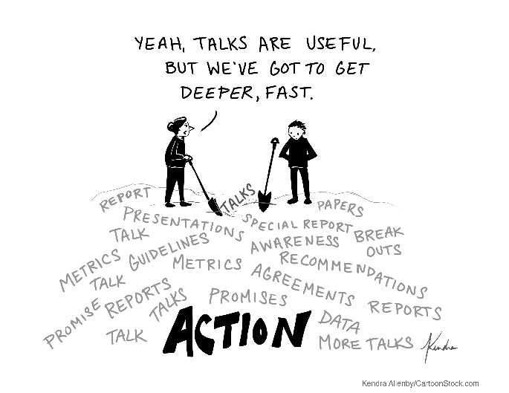 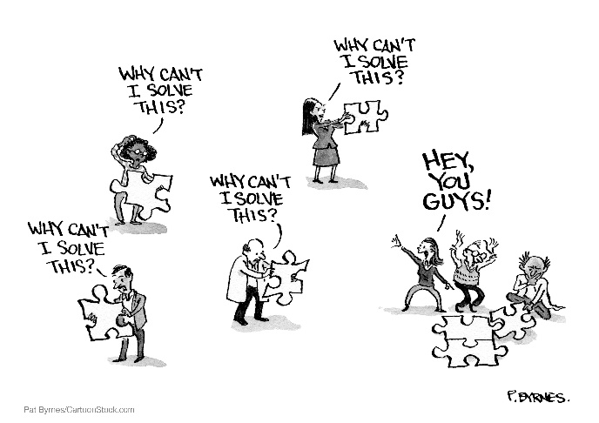

We are excited to be inviting you to the 4th virtual Climate and YOUth Summit. Organized by the IFRC, the American Red Cross and the Climate Centre, in partnership with the Norwegian Red Cross, it brings together young people from the Red Cross Red Crescent Movement and other youth-led organizations around the world.   
  
It’s a great opportunity to share knowledge, experiences, promote capacity building and inspire youth-led climate action. This year’s summit will focus on youth-led innovations, projects and solutions to tackle climate challenges globally.

You can find more information and submit a session proposal up to 23 October [here](https://forms.office.com/e/BGuPHS6x6v).   
  
Register to attend [here](https://forms.office.com/e/7mnACLCFfa).

**📅 Date**: 11 December 2024

**💻 Location**: Virtual

**🌍 Simultaneous translation in Arabic, French and Spanish organized by volunteers**

**What’s in it for you?**

* Share your knowledge and experience
* Meet youth leaders and experts from the Red Cross Red Crescent and beyond
* Showcase your climate projects and innovations
* Build global partnerships for future actions.

**How to get involved?**

Are you passionate about climate action? Do you want to learn from different topics, engage in meaningful discussion and connect with other youth leaders? Save the date for the Climate and YOUth Summit 2024 and don’t miss out on this opportunity!

**Host a session**

Do you have ideas, experiences, or skills you want to share with other young leaders at a global level? This is your chance to lead the conversation. Host a 15-, 45- or 90-minute session and inspire others to take climate action.

**Agenda**

Stay tuned. The full agenda of sessions and speakers will be announced soon. We are really excited by your interest in joining the Climate and YOUth Summit 2024.If you have any question, you can contact Ana Mejia at *youth@climatecentre.org*.

