**Climate & YOUth Summit 2024   
The role of youth in climate action  
11 December online**

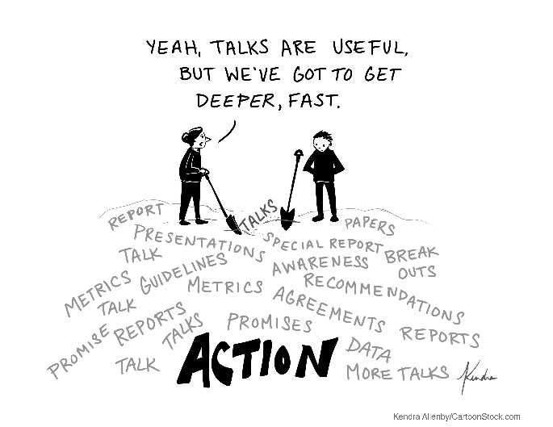 

We are excited to be inviting you to the fourth virtual Climate & YOUth Summit! The online Climate & YOUth Summit 2024, organized by the Climate Centre, the IFRC, and the American Red Cross, in partnership with the Norwegian Red Cross and the Big Six Youth Organizations Global Youth Mobilization initiative, brings together young leaders from the RCRC Network and other youth-led organizations around the world.   
  
It will be the opportunity to share knowledge, experiences, promote capacity building and inspire youth-led climate action. This year’s Summit will focus on the role of youth in climate action, spotlighting youth-led innovations, projects and solutions to tackle climate challenges globally.

You can find more information and submit a session proposal before 13 November 2024 [here](https://forms.office.com/pages/responsepage.aspx?id=kJer0-Jq2EuqXgKGRIPnx9-JfE2ukwRHq6C1NgyXF-pURU9ISTk1NTZVME1aUUwzUTNDQ0pCODgyOS4u&route=shorturl).

**📅 Date**: 11 December 2024

**💻 Location**: Virtual

**🌍** Sessions will be available in English, Spanish, French, and Arabic.

**What’s in it for you?**

* Share your knowledge and experiences
* Connect with youth leaders and experts from the Red Cross Red Crescent network and beyond
* Showcase your climate projects and innovations
* Build global partnerships and inspire future actions

**Attend**

Are you passionate about climate action? Do you want to learn from different topics, engage in meaningful discussion and connect with other youth leaders?

Save the date for the Climate & YOUth Summit 2024 and don’t miss out this opportunity!

You can register to attend the summit [here](https://forms.office.com/pages/responsepage.aspx?id=kJer0-Jq2EuqXgKGRIPnx9-JfE2ukwRHq6C1NgyXF-pUODc2RzRMTUI3UEJSM1NEVFBFT0pCSjVFTy4u&route=shorturl).

**Host a session**

Do you have ideas, experiences, or skills you want to share with other young leaders at a global level? This is your chance to lead the conversation! [Host a 15-, 45-, or 90-minute session](https://forms.office.com/pages/responsepage.aspx?id=kJer0-Jq2EuqXgKGRIPnx9-JfE2ukwRHq6C1NgyXF-pURU9ISTk1NTZVME1aUUwzUTNDQ0pCODgyOS4u&route=shorturl) and inspire others to take climate action.

**Agenda**

Stay tuned! The full agenda of sessions and speakers will be announced soon.

We are really excited for your interest in joining the Climate & YOUth Summit 2024, if you have any question, you can contact Ana Mejia at: youth@climatecentre.org.

